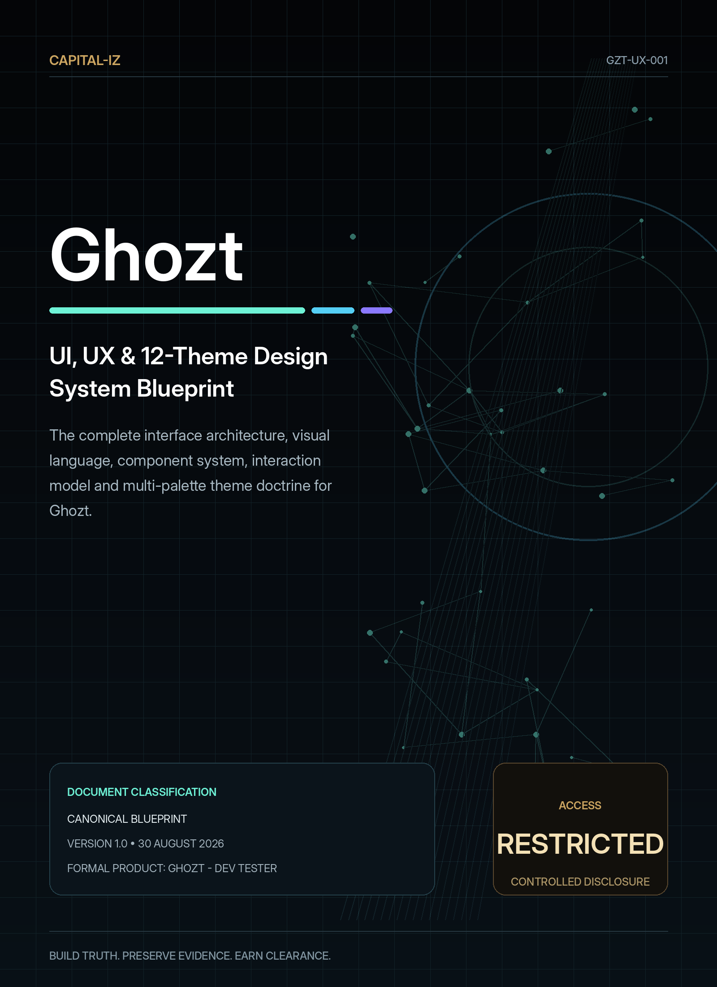

DOCUMENT CONTROL

Ghozt UI, UX & 12-Theme Design System Blueprint
Defines every major visible and interactive layer of Ghozt: shell architecture, workspaces, components, state language, motion, accessibility, responsiveness and the complete multi-palette theme engine.
Document code | GZT-UX-001
Product | Ghozt - Dev Tester
Visible brand | Ghozt
Portfolio identity | Capital-Iz Ghozt
Version | 1.0
Issue date | 30 August 2026
Status | Canonical design and technical blueprint
Scope | Desktop-first application shell for Windows 11 Pro, with extension-ready patterns for web, mobile monitoring and future platforms.
Authority | Capital-Iz product and engineering governance
Source inheritance | Capital-Iz Dev Tester Platform Blueprint; Universal Blueprint Development Doctrine; AI Architecture Blueprint; Universal Design System; CommandDeck implementation reference

CONTROLLED INTERPRETATION
This blueprint defines intended product behaviour and design authority. It does not authorise unbounded access to third-party systems. Ghozt must operate only against targets, environments and actions for which the operator has explicit permission.

01 • EXPERIENCE AUTHORITY

Design mandate
Ghozt’s interface must feel like a restricted software-examination facility: futuristic, professional, forensic and slightly illicit, while remaining clearer and more dependable than the systems it examines.
EXPERIENCE THESIS
The operator should feel that Ghozt is inside the target, seeing state and sequence that ordinary testing surfaces cannot—without ever losing the target, authority, evidence or next action.

Capital-Iz family rules inherited
- Clarity over decoration.
- High-contrast structure with restrained premium accents.
- Every visual element carries orientation, priority, evidence or action.
- Operational layouts may be dense, but must remain readable.
- Risk, state, ownership and current action are visible.
- Controls are action-first and reusable.
- Decorative clutter may never hide workflow meaning.
- Structure → Validation → Execution → State → Event → Audit remains visible in the interface.

Ghozt-specific interpretation
Family characteristic | Ghozt expression
Premium dark operational shell | Colder void surfaces, spectral telemetry, precision borders and restricted-status plates.
CommandDeck’s layered glass and glow | Retained as an optional finish system, but colder and more localised; never copied as the same screen.
CommandDeck’s persistent work areas | Reinterpreted as status strip, operations rail, state lattice, forensic inspector and black-box stream.
Rounded modular controls | Tighter radii, occasional chamfers, interrupted borders and measurement-like separators.
Gold-led authority | Gold is reserved for evidence seals, approvals, release clearance and Capital-Iz authority.
Responsive operational layout | Panels collapse, dock, detach and reflow according to available width and operator context.

02 • UNIQUE DESIGN DIRECTION

Visual personality: Spectral Forensics
The word “ghost” is not illustrated literally. Ghozt’s presence is expressed through behaviour: explored states materialise, recent paths leave a spectral afterimage, intermittent faults phase in and out, evidence resolves hidden structure, and verified states become visually solid.
Use | Visual expression | Reason
Autonomous traversal | A narrow moving trail with short-lived afterimage across the State Lattice. | Shows where the system has been without permanently cluttering the map.
Untested state | Low-opacity node, interrupted border and muted label. | Makes missing coverage visible without equating it to failure.
Verified state | Solid structure, stable border and evidence-linked seal. | Signals that expected behaviour is proven, not merely visited.
Phantom fault | Ultraviolet phase shimmer used briefly when evidence appears or disappears. | Communicates intermittence without constant flicker.
Causal chain | Sequential illumination from trigger to deviation to evidence. | Makes time and dependency legible.
Counterfactual branch | Dotted violet branch from the observed timeline. | Separates hypothetical variation from observed fact.
Restricted action | Gold authority rail plus explicit permission copy. | Signals privilege and review, not generic emphasis.

Prohibited aesthetic shortcuts
- Matrix rain, random hexadecimal text, skulls, hooded figures, fake intrusion maps or permanent CRT distortion.
- Continuous flicker, bloom around every element, decorative noise behind evidence or aggressive red for ordinary activity.
- A full-screen terminal metaphor for functions that require spatial, visual or comparative understanding.
- Ghost puns used as primary action labels when a direct technical verb is clearer.
- Copying CommandDeck’s radial launcher, exact gold treatment, corner radii or panel composition.
- Theme changes that alter the meaning of verified, warning, fault, critical, AI or authority states.
03 • TWELVE PALETTES, THREE MODES

Theme system architecture
Ghozt must ship with at least ten complete palettes. This blueprint defines twelve. Each palette is a coherent design identity with Dark, Light and System modes, semantic-token derivation and optional surface finishes. Themes are not superficial colour swaps; they preserve contrast, hierarchy, state meaning and component behaviour.
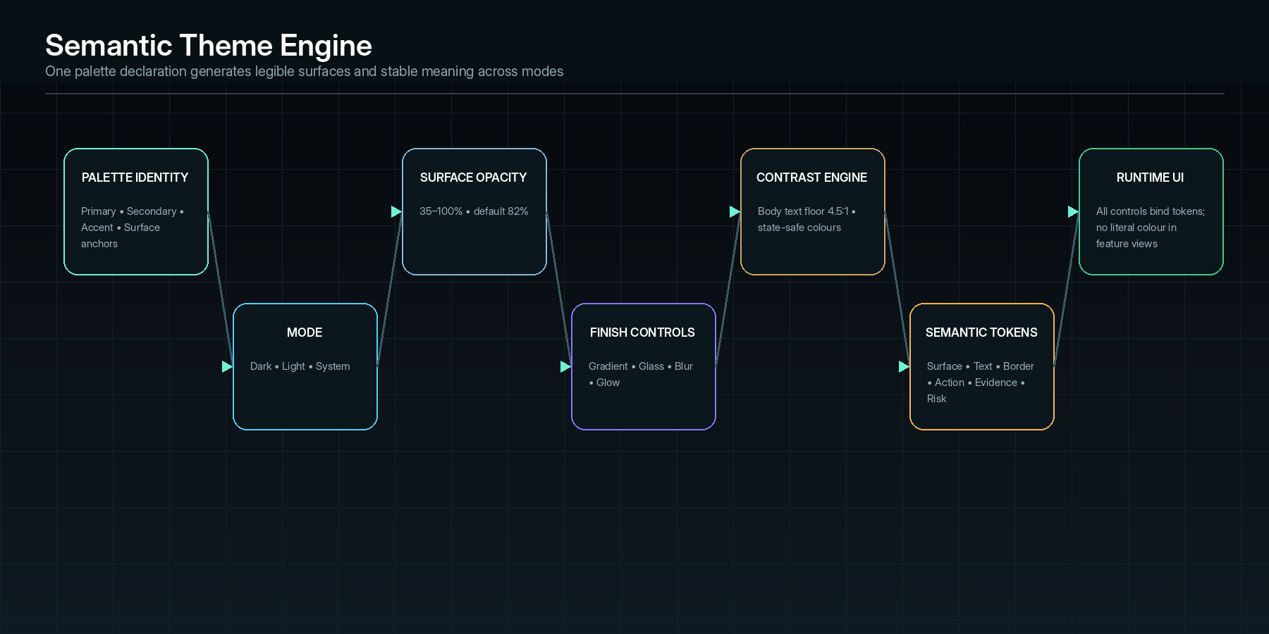
The theme engine separates palette identity, display mode, opacity and finish controls from semantic UI meaning.

Theme model
Layer | Definition | Non-negotiable behaviour
Palette identity | Named primary, secondary, accent and surface anchors. | One palette declaration generates all surface, text, border, action and wash tokens.
Mode | Dark, Light or System. | System follows the operating-system setting while retaining the selected palette identity.
Surface opacity | How strongly desktop/background context can show through large surfaces. | Range 35–100%; default 82%; text, borders and status colours remain stable and readable.
Finish: gradient | Optional controlled wash across surfaces. | Must be included in contrast calculation; disabling it restores a clean flat version.
Finish: glass | Optional translucency, frost and blur impression. | Never presented as real privacy or hardware blur when it is only visual treatment.
Finish: glow | Optional edge/shadow emphasis. | Localised to active traversal, selection, evidence or risk—never a permanent halo around the whole UI.
Contrast engine | Automatic adjustment of text and accent fills. | Normal body text target is at least 4.5:1 against the composited reading surface.
Semantic status layer | Verified, warning, fault, critical, AI/counterfactual and authority colours. | Meaning remains stable across all twelve palettes and all modes.

COMMANDDECK IMPLEMENTATION LESSON
CommandDeck demonstrates the correct family architecture: a small palette declaration can generate dark and light tokens, enforce a 4.5:1 text contrast floor, expose 35–100% surface opacity with an 82% default, and independently control gradient, glass, blur and glow. Ghozt adopts that architectural discipline with its own palettes and semantic namespace.

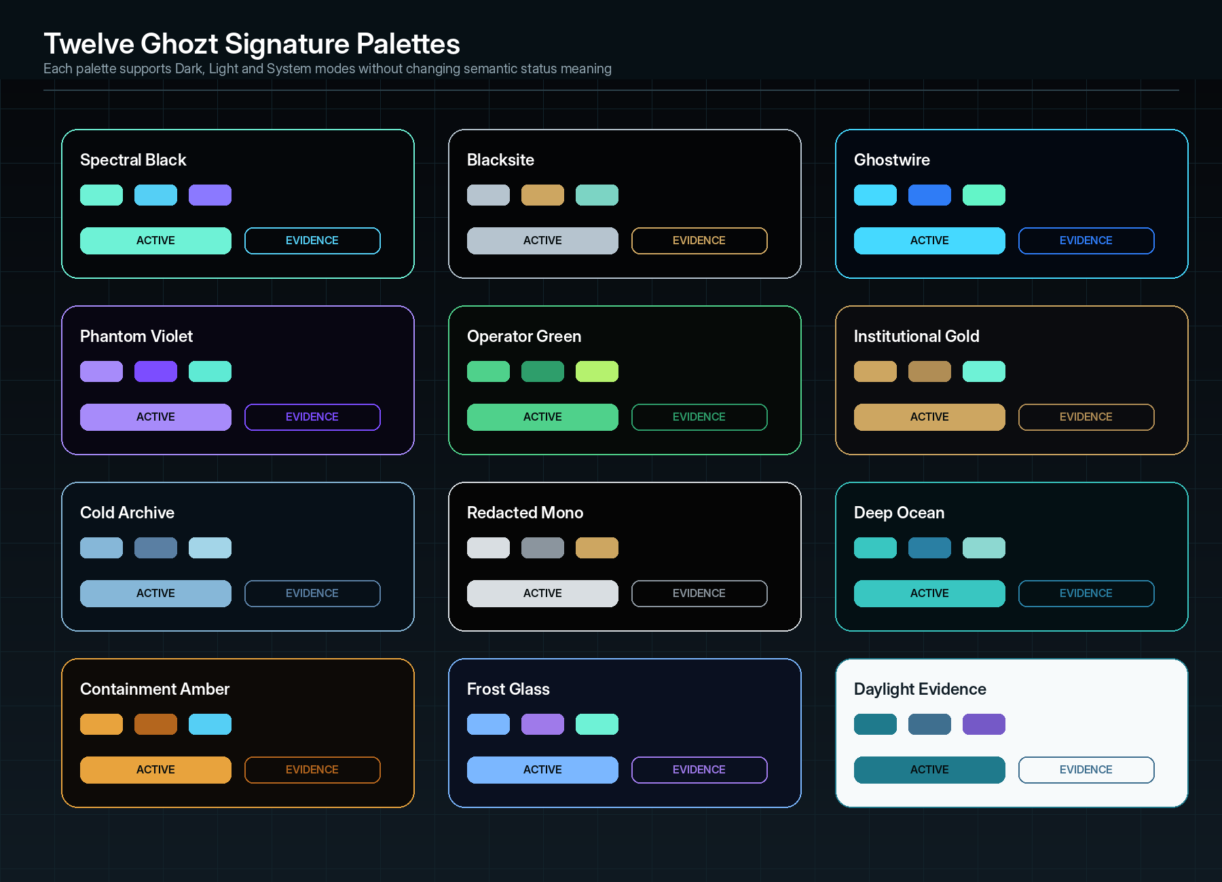
The twelve Ghozt palette identities. Dark, Light and System modes are available under every named palette.

Twelve signature palettes
Theme | Intent | Primary | Secondary | Accent | Dark Base | Light Base
Spectral Black | Default restricted-forensics identity; balanced and unmistakably Ghozt. | #6EF2D6 | #55CFF5 | #8B79FF | #05070A | #EEF6F5
Blacksite | Severe, covert and executive; gold carries authority. | #B6C4CF | #CDA661 | #7CD4C4 | #040506 | #F1F3F4
Ghostwire | High-energy telemetry and live traversal. | #45D9FF | #2F7CF6 | #63F5C8 | #030811 | #EDF8FC
Phantom Violet | Counterfactual reasoning, AI hypotheses and intermittent faults. | #A78BFA | #7C4DFF | #5EEAD4 | #080612 | #F5F1FF
Operator Green | Focused long-session terminal and operations posture. | #4FD18B | #2E9E6B | #B5F26E | #060A08 | #F0F8F3
Institutional Gold | Premium Capital-Iz authority and formal review. | #CDA661 | #B08D55 | #6EF2D6 | #0B0C0F | #F7F4EE
Cold Archive | Calm evidence review and long-form forensic reading. | #86B7D8 | #5A7FA3 | #A3D5E8 | #071018 | #F2F7FA
Redacted Mono | Near-monochrome restricted-document and compliance character. | #D9DEE2 | #8B959E | #CDA661 | #050505 | #F4F4F3
Deep Ocean | Technical calm with subtle teal intelligence. | #39C6C1 | #2A7FA3 | #8DD8D1 | #041014 | #EDF8F7
Containment Amber | Risk analysis, unstable environments and active containment. | #E8A33D | #B4661E | #55CFF5 | #0D0A07 | #FBF5EA
Frost Glass | Premium luminous lab interface with maximum depth. | #7BB7FF | #9F7AEA | #6EF2D6 | #0A1020 | #F4F7FC
Daylight Evidence | High-readability light-first forensic and reporting environment. | #1F7A8C | #3F6F8F | #7559C7 | #081015 | #F7FAFB

Theme profiles: operational intent and default finish
Theme | Best suited to | Default finish | Surface anchors
Spectral Black | Daily operation, State Map, forensic runs | Glass on • gradient subtle • glow restrained | Dark: #05070A / #091017 / #101A22  Light: #EEF6F5 / #F8FCFB / #DCEBE8  Opacity: 82%
Blacksite | Clearance, controlled environments, client demos | Glass low • flat surfaces • edge glow only | Dark: #040506 / #0B0E11 / #14191D  Light: #F1F3F4 / #FFFFFF / #E2E6E8  Opacity: 88%
Ghostwire | Live sweeps, network/API inspection | Gradient on • glass medium • scan glow | Dark: #030811 / #071523 / #0E2638  Light: #EDF8FC / #FFFFFF / #D6EEF7  Opacity: 78%
Phantom Violet | Counterfactual Lab, AI analysis, Phantom faults | Glass on • violet wash • low bloom | Dark: #080612 / #141027 / #211A3A  Light: #F5F1FF / #FFFFFF / #E8DFFF  Opacity: 80%

Theme | Best suited to | Default finish | Surface anchors
Operator Green | Black-box logs, queues, local test operation | Flat/low gradient • glow minimal | Dark: #060A08 / #0D1511 / #16251D  Light: #F0F8F3 / #FFFFFF / #DDEEE4  Opacity: 84%
Institutional Gold | Reports, approvals, certificates, executive review | Glass low • gold edge • no loud bloom | Dark: #0B0C0F / #16171A / #202227  Light: #F7F4EE / #FFFDF8 / #E9E1D4  Opacity: 90%
Cold Archive | Evidence Vault, report inspection, audit | Flat • no gradient default • shadow only | Dark: #071018 / #0E1C27 / #172B39  Light: #F2F7FA / #FFFFFF / #DFEAF1  Opacity: 92%
Redacted Mono | Sensitive reviews, redaction, accessibility | Flat • glass off • accent used sparingly | Dark: #050505 / #101112 / #1B1D1F  Light: #F4F4F3 / #FFFFFF / #E1E2E0  Opacity: 94%

Theme | Best suited to | Default finish | Surface anchors
Deep Ocean | Multi-service architecture and data flows | Glass medium • depth gradient • soft glow | Dark: #041014 / #09232A / #103A43  Light: #EDF8F7 / #FFFFFF / #D6EDEB  Opacity: 83%
Containment Amber | Risk Control, destructive tests, incident modes | Flat • warning edge • pulse only on events | Dark: #0D0A07 / #181310 / #231A15  Light: #FBF5EA / #FFFFFF / #F1DFC1  Opacity: 88%
Frost Glass | Presentation, exploration, multi-monitor labs | Glass high • gradient on • blur 18–24 • glow low | Dark: #0A1020 / #121C31 / #1E2D49  Light: #F4F7FC / #FFFFFF / #E2EAF7  Opacity: 72%
Daylight Evidence | Day work, print review, client-facing analysis | Light flat default • glass off • crisp borders | Dark: #081015 / #111B20 / #18262C  Light: #F7FAFB / #FFFFFF / #E8EFF2  Opacity: 100%

Global semantic colours
Semantic role | Anchor | Meaning and usage
Ghozt active / traversal | #6EF2D6 | Current agent path, observation, connected state and primary live activity.
Live telemetry / information | #55CFF5 | Network, API, service and streaming information.
AI / counterfactual | #8B79FF | Hypotheses, simulated branches, model reasoning and Phantom states.
Capital-Iz authority | #CDA661 | Approval, evidence seal, trusted verdict, release clearance and formal certification.
Verified | #42C98A | Expected behaviour proven with evidence.
Warning / review | #FFB44A | Uncertainty, blocked scope, degraded operation or review required.
Fault | #FF5968 | Confirmed failure under a declared condition.
Critical / containment | #D92F4C | Immediate risk, destructive failure or containment action.

SEMANTIC STABILITY
A palette may tint ordinary surfaces and actions, but it must never make a fault look verified, a simulation look observed, or an authority decision look like ordinary selection.

04 • SYSTEM PRIMITIVES

Design foundations and tokens

Geometry
Token family | Recommended values | Use
Outer shell radius | 20–24 px | Main application window, floating workspaces and principal overlays.
Primary panel radius | 16–18 px | Navigation rail, central canvases, inspectors and drawers.
Evidence / data card radius | 12–16 px | Findings, events, hypotheses, test cases and report blocks.
Compact control radius | 8–12 px | Inputs, chips, segmented controls, icon buttons and small tiles.
Pill radius | 50% of height | Status chips, filters and binary state controls only.
Chamfer / clipped corner | 4–10 px on one corner | Restricted actions, evidence seals and key forensic surfaces; use sparingly.
Border weight | 1 px standard; 2 px selected/risk; 3 px clearance seal | Communicates structure and state without heavy chrome.

Spacing and density
Scale | Value | Primary use
2 | 2 px | Micro alignment, icon optical adjustment.
4 | 4 px | Compact inline gaps.
8 | 8 px | Control internals and dense rows.
12 | 12 px | Small card padding and grouped controls.
16 | 16 px | Default panel/card spacing.
24 | 24 px | Section separation and large card padding.
32 | 32 px | Workspace gutters and major grouping.
48 | 48 px | Hero / empty-state spacing.

Default density is compact-professional. A user may select Compact, Standard or Comfortable density, but critical target, risk and evidence information must never be removed—only reflowed.

Typography
Role | Typeface / treatment | Guidance
Display / workspace title | Inter Display Semibold, 24–34 px | Use sparingly for orientation; never all caps for long titles.
Section heading | Inter Display Semibold, 16–22 px | Clear hierarchy above grouped content.
Body / controls | Inter Regular or Medium, 13–15 px | Optimised for dense desktop reading.
Metadata / labels | Inter Medium, 11–12 px, uppercase optional | Short technical labels only.
Code / raw logs / IDs | Monospaced font with tabular figures, 11–13 px | Preserve alignment and distinguish raw evidence from narrative.
Numeric telemetry | Tabular numerals, medium weight | Avoid value jitter during live updates.

Elevation and depth
- Depth is created through surface contrast, one controlled shadow tier and local edge illumination.
- Glass and blur are optional finish controls, not structural requirements.
- Selected objects use an illuminated side rail, border interruption or evidence seal before adding glow.
- Critical overlays may darken the surrounding interface, but must keep target and environment visible.
- No more than three apparent elevation tiers should exist in a single workspace.
05 • PERSISTENT OPERATOR FRAME

Application shell architecture
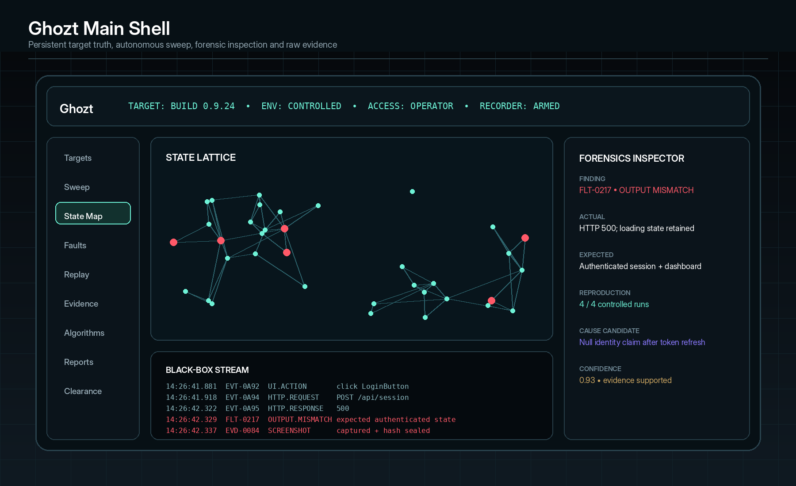
Reference shell: status strip, operations rail, State Lattice, forensic inspector and black-box stream.

Shell regions
Region | Persistent responsibility | Minimum content
Restricted status strip | Expose the current truth about what Ghozt is examining and what it is permitted to do. | Ghozt, target, build/commit, environment, connection, access class, run mode, recorder state and active warnings.
Operations rail | Move between lifecycle workspaces without losing run context. | Targets, Sweep, State Map, Faults, Replay, Evidence, Algorithms, Regressions, Reports, Clearance and Settings.
Workspace header | Orient the user inside the selected module. | Workspace title, project/target scope, breadcrumb, filters, primary action and contextual status.
Primary canvas | Host the main task: map, table, timeline, editor, report or comparison. | Content-specific controls with stable selection and loading state.
Forensics inspector | Expose details and actions for the current selection. | Actual, Expected, Difference, Causality, Reproduction, Counterfactuals, Evidence, Fix and Re-test.
Black-box tray | Present raw time-ordered execution and evidence intake. | Time, event ID, source, category, action/result, severity, evidence link and filters.
Global command surface | Fast search and action execution. | Command palette, shortcut help, target switcher, theme control and recent items.

Shell behaviour
- The status strip stays visible during navigation, overlays, full-screen graphs and report review.
- The selected target and build never reset implicitly when switching workspaces.
- The right inspector follows selection; it may pin, compare or detach to another monitor.
- The black-box tray supports collapsed, peek, half-height and detached states.
- The main canvas saves zoom, pan, filters and selection per workspace and target.
- Unsaved plans, annotations or approvals show an explicit dirty state before navigation.
- A global emergency stop remains reachable during active execution and clearly distinguishes stop, pause, cancel-after-step and containment.
06 • PRIMARY NAVIGATION

Workspace architecture
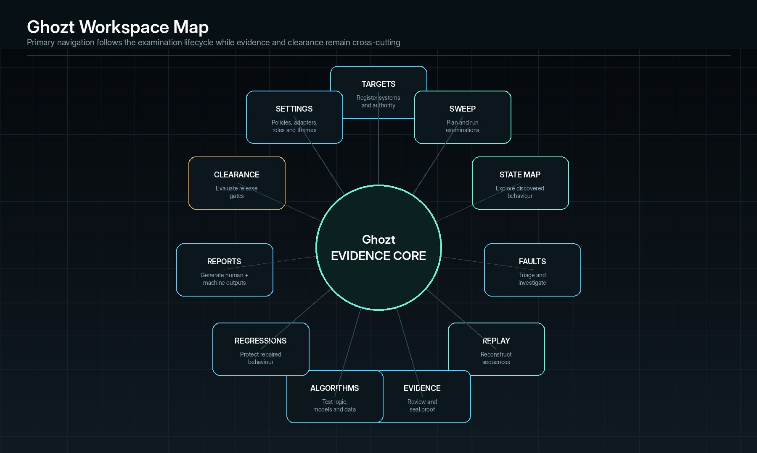
Workspaces follow the examination lifecycle and share one evidence core.
Workspace | Purpose | Core interface
Targets | Register local apps, repositories, builds, environments, credentials, devices and explicit authority. | Target cards, environment badges, health checks, capability matrix, permission scope and last-known evidence.
Sweep | Plan, budget, approve, execute and monitor autonomous examinations. | Scope builder, discovery manifest, risk budget, agent plan, live queue, stop controls and coverage progress.
State Map | Explore the connected graph of features, states, transitions, endpoints, services, data and evidence. | Lattice canvas, legends, filters, path search, confidence overlays, diff mode and inspector.
Faults | Triage confirmed deviations and unstable Phantom findings. | Fault queue, severity, reproducibility, owner, evidence completeness, cause status and fix readiness.
Replay | Reconstruct exact sequences and compare successful, failing and counterfactual runs. | Timeline, frame/event synchronisation, network trace, state diff, breakpoints, branch controls and minimiser.
Evidence | Search, inspect, seal, redact, retain and export raw artefacts. | Evidence viewer, chain of custody, hash status, annotations, redaction, provenance and retention policy.
Algorithms | Test deterministic algorithms, probabilistic models, datasets, invariants and expected outputs. | Harness editor, datasets, parameter sweep, oracle/invariant builder, distribution charts, drift and reproducibility.
Regressions | Manage guards generated from features and confirmed faults. | Suites, ownership, freshness, mutation resilience, flake rate, affected builds and required gates.
Reports | Create technical, executive, client and machine-readable outputs. | Dossier builder, templates, evidence links, sign-off, exports and report history.
Clearance | Evaluate release policy and issue pass, conditional clearance, denial or waiver. | Gate matrix, residual risk, exceptions, approvals, signatures, certificate and release-system integration.
Settings | Configure roles, policies, adapters, agents, secrets, themes, retention and integrations. | Governed registries with change history and validation.

07 • SIGNATURE VISUAL SYSTEM

State Lattice
The State Lattice is Ghozt’s signature interactive surface. It represents the target as a navigable, evidence-linked graph rather than a list of test scripts. It must remain useful at system, feature, workflow, state, event and evidence levels.
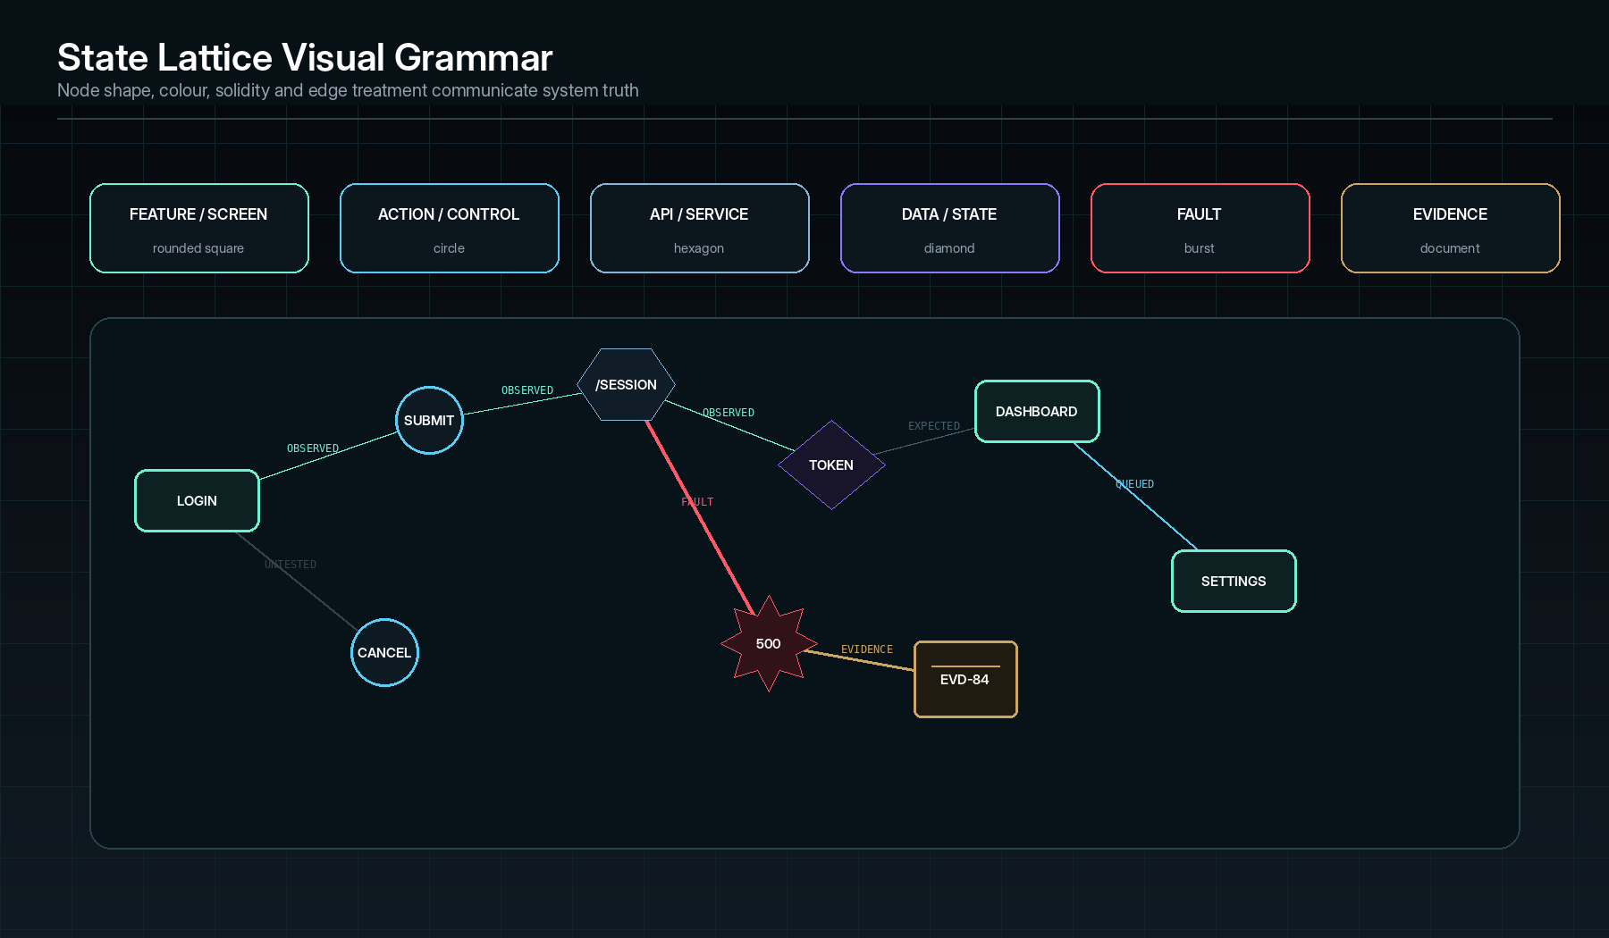
Recommended visual grammar for nodes, edges, observation states and evidence.

Lattice entities
Entity | Representation | Required metadata
System / product | Large bounded region or root node. | Target ID, owner, build, environment and authority.
Feature / screen | Rounded rectangular node. | Feature ID, description, owner, expected states and coverage.
Action / control | Circular node. | Control ID, input, permission, side effects and accessible name.
Route / endpoint / service | Hexagonal node. | Method, path, contract, dependency, auth and telemetry.
Data / application state | Diamond node or state band. | Schema/value class, source, before/after, sensitivity and persistence.
Algorithm / model | Specialised processor node. | Version, parameters, dataset, invariants, oracle and confidence.
Fault | Burst or interrupted red node. | Fault ID, severity, reproducibility, first/last seen and causal status.
Evidence | Document/seal node. | Evidence ID, type, hash, time, source, retention and access.
Counterfactual branch | Dotted ultraviolet edge or branch. | Changed factor, predicted effect, observed result and confidence.

Zoom levels
Level | Question answered | Default contents
System | Which areas exist and where is risk concentrated? | Products, subsystems, integrations, coverage heat and major faults.
Feature | Which workflows and expected states define this feature? | Screens, routes, inputs, outputs, permissions and guards.
Workflow | Which sequence connects intent to result? | Actions, transitions, calls, waits, state deltas and branches.
State | What was true at this moment? | UI tree, data snapshot, session, permissions, network and resources.
Event | What exactly changed, by whom and why? | Actor, source, timestamp, parameters, before/after and result.
Evidence | What proves the conclusion? | Raw artefact, hash, capture method, annotations and chain of custody.

Lattice interactions
- Pan, zoom, semantic zoom and fit-to-scope.
- Search by feature, route, event, fault, evidence, build, owner or state value.
- Filter by tested status, severity, agent, environment, evidence completeness and time.
- Select a node to open the inspector; Shift-select for comparison; pin for persistent monitoring.
- Trace upstream cause candidates or downstream affected paths.
- Display observed, expected, previous-build or counterfactual overlays.
- Play autonomous traversal as a time-controlled path.
- Collapse low-value nodes into summarised clusters without losing drill-down.
- Export a stable snapshot with legend, target, build and timestamp.
NO DECORATIVE GRAPH
Every visible node and edge must resolve to real target metadata, a planned test, an observed event, an expected contract, an evidence artefact or an explicit inference. The lattice must not invent structure merely to look complex.

08 • CONTEXTUAL TRUTH PANEL

Forensics Inspector
The right-side inspector is the primary bridge between visual overview and defensible detail. It follows selection, keeps context stable and exposes the exact evidence behind summaries.
Inspector tab | Purpose | Required controls
Overview | Summarise identity, state, severity and current decision. | IDs, target/build, owner, status, confidence, timestamps and primary action.
Actual | Show the observed result and state. | Rendered result, structured values, before/after, raw links and capture time.
Expected | Show the governing contract or oracle. | Source requirement, assertion, tolerance, version and acceptance criteria.
Difference | Explain exact mismatches. | Semantic diff, field/path comparison, visual diff, threshold and ignored changes.
Causality | Rank cause hypotheses and supporting/contradicting evidence. | Hypothesis cards, confidence, evidence links, dependency path and challenge action.
Reproduction | Define and execute the reproducer. | Preconditions, sequence, inputs, environment, repetitions, success rate and minimised path.
Counterfactuals | Vary one or more causal factors under control. | Branch editor, changed factor, result, comparison and confidence.
Evidence | Inspect all bound artefacts. | Viewer, hashes, provenance, annotation, redaction and export.
Fix | Generate or review a bounded repair brief. | Affected files/components, strategy, risk, forbidden changes, required tests and agent permission.
Re-test | Run minimal and adjacent verification. | Selected suite, environment, expected result, run controls and verdict.

Inspector presentation rules
- Tabs with unavailable content remain visible with an explicit reason, rather than disappearing.
- Observed fact, computed metric, AI inference and human judgement use distinct labels.
- Confidence is displayed with source and calibration context—not as decorative precision.
- Every recommendation has a “Why?” path to supporting evidence and assumptions.
- The inspector may be widened, detached or locked to a pinned item for side-by-side work.
- Destructive or privileged actions include target, environment, effect and approval in the action surface.
09 • RAW OPERATIONAL RECORD

Black-box stream and event surfaces
The black-box stream is not a decorative terminal. It is a structured, time-synchronised evidence surface that can be read quickly while retaining the exact raw record.
14:26:41.881 EVT-0A92 UI.ACTION click LoginButton actor=AGT-04
14:26:41.906 EVT-0A93 STATE.DELTA isLoading false -> true src=UI
14:26:41.918 EVT-0A94 HTTP.REQUEST POST /api/session trace=TRC-19A
14:26:42.322 EVT-0A95 HTTP.RESPONSE 500 dur=404ms
14:26:42.329 FLT-0217 OUTPUT.MISMATCH expected authenticated sev=HIGH
14:26:42.337 EVD-0084 SCREENSHOT captured + hash sealed sha256=…

Field | Interface behaviour
Timestamp | Show local time with millisecond precision; allow switch to UTC, relative and monotonic sequence.
ID | Selectable and copyable; opens event or finding inspector.
Source/category | Filterable icon + text; colour supports but never replaces the label.
Message | Human-scannable summary with expandable structured payload.
Trace relationship | Jump to parent/child event, request, span, action or state delta.
Evidence | Indicate capture, hash, redaction and chain-of-custody state.
Severity | Stable semantic badge; do not colour the entire row unless critical.
Live control | Pause visual streaming without stopping execution; resume without losing events.

Stream views
- Unified chronological stream.
- UI actions and accessibility tree.
- Network and service trace.
- Application logs and exceptions.
- State and data deltas.
- Resource, performance and device telemetry.
- Agent decisions, tool calls and approvals.
- Evidence capture and sealing events.
- Security and permission events.
- User annotations and review decisions.
10 • REUSABLE COMPONENT SYSTEM

Complete UI element catalogue

Application chrome
Component | Contract
GhoztTitleBar | Window drag region, target summary, connection, global search, theme and window controls.
RestrictedStatusStrip | Persistent target/build/environment/access/run/recorder truth.
OperationsRail | Primary workspace navigation with compact and expanded modes.
WorkspaceHeader | Breadcrumb, title, scope, filters, status and primary actions.
PanelDock | Dock, resize, collapse, pin, detach and restore panels.
BlackBoxTray | Raw event stream in collapsed, peek, expanded and detached modes.
CommandPalette | Search targets, workspaces, entities and governed actions.
GlobalEmergencyControl | Pause, stop, cancel-after-step, contain and explain effects.

Actions and input
Component | Contract
PrimaryActionButton | One dominant local action; label uses a direct verb.
SecondaryButton | Non-destructive adjacent action.
QuietButton | Low-priority inline action.
IconButton | Icon plus accessible name and tooltip; never icon-only for ambiguous critical action.
SplitButton | Default action plus governed alternatives.
DestructiveActionButton | Red semantic treatment, exact target/effect and confirmation.
ApprovalButton | Gold authority rail, approver identity and policy context.
ToggleSwitch | Persistent binary setting; not for immediate commands.
SegmentedControl | Small mutually exclusive view or mode choices.
SearchField | Search syntax, scope chips, saved query and clear state.
CodeOrQueryEditor | Monospaced editor with validation, line numbers and safe execution controls.
SecretField | Masked input with provider reference; no uncontrolled secret reveal.
TargetPicker | Target, build and environment grouped together to prevent context errors.
RangeSlider | Budget, confidence, time or resource range with visible values.
FileDropZone | Typed acceptance, scanning status and provenance.

State and feedback
Component | Contract
StatusBadge | Text + icon + stable semantic colour.
SeverityBadge | Info, low, medium, high and critical with accessible label.
ConfidenceIndicator | Value, band and evidence/calibration source.
CoverageMeter | Verified, failed, blocked, waived and untested segments.
ProgressRail | Current phase, completed phases and next gate.
LivePulse | Brief event indication; never permanent animation.
Toast | Non-blocking outcome with action and evidence link.
InlineValidation | Specific input error, correction and affected action.
BlockingBanner | Permission, target, environment or service state that blocks execution.
EmptyState | Explains why no data exists and gives the next valid action.
Skeleton | Structure-preserving loading state.

Data and analysis
Component | Contract
EvidenceTable | Sortable, filterable, column-managed, virtualised and exportable.
FindingCard | Severity, title, reproduction, confidence, evidence and owner.
HypothesisCard | Claim, supporting/contradicting evidence, confidence and challenge action.
TestCaseCard | Intent, preconditions, steps, expected outcome, owner and regression state.
RunCard | Target, build, environment, scope, status, evidence and duration.
DiffViewer | Text, JSON, DOM, image, table, model and state differences.
Timeline | Synchronised events with zoom, lanes, markers and breakpoints.
Waterfall | Requests, tasks, spans or algorithm stages with duration and dependencies.
Heatmap | Coverage, latency, risk or fault frequency with accessible data table.
MetricTile | Single metric plus definition, scope, trend and quality warning.
Chart | Accessible quantitative visual with data export and no decorative 3D.
TreeView | Hierarchy with lazy loading, search and stable selection.
VirtualisedLogGrid | High-volume logs with structured columns and raw payload.

Forensics and evidence
Component | Contract
StateNode | Typed node with observed/expected/verified status.
TransitionEdge | Typed relationship with sequence, condition and evidence.
FaultFingerprint | Stable signature from exception, state, path, output and environment.
ReproductionMatrix | Conditions versus attempts, outcomes and evidence.
CounterfactualBranch | Alternative factor and result, visibly separated from observed history.
CausalChain | Trigger, enabling conditions, deviation and downstream effect.
EvidenceViewer | Images, video, audio, logs, traces, documents and structured payloads.
ChainOfCustodyPanel | Actor, source, capture, hash, access, transformation and retention.
RedactionTool | Mask sensitive regions or fields while preserving original under permission.
EvidenceSeal | Verification, hash and reviewer state; gold only when complete.
AnnotationLayer | Timestamped, attributable notes anchored to evidence.

Overlays and governed decisions
Component | Contract
InspectorDrawer | Contextual, pinnable and detachable detail panel.
ModalDialog | Single bounded decision; no nested modal chains.
ApprovalSheet | Policy, target, effect, evidence and approver.
DestructiveGate | Typed confirmation and optional second approver.
PermissionGate | Required role, missing permission and request path.
ConflictDialog | Competing edits, runs or state with compare and resolution.
RunPlanReview | Scope, agents, actions, budgets, risks, exclusions and evidence plan.
ClearanceDecisionSheet | Gate results, residual risk, waivers, signatures and issue action.

11 • SCREEN-BY-SCREEN BLUEPRINT

Workspace-specific interface specification

Targets
- Target registry with card and table views; search by project, product, repository, environment and status.
- Target onboarding wizard: identify target type, ownership, build source, launch method, endpoints, credentials, reset hooks, data sensitivity and permission scope.
- Capability probe showing available UI driver, source access, API access, logs, traces, database, device, container and CI integration.
- Environment colour band and persistent production warning treatment.
- Target health panel with connection, launch, authentication, instrumentation and reset validation.
- History of builds, manifests, runs, findings, evidence and clearance.

Sweep
- Scope composer that can select product, subsystem, feature, route, endpoint, algorithm, risk class and changed files.
- Run-mode presets: smoke, changed-area, full sweep, deep forensic, performance, security-authorised, algorithm validation and deployment certification.
- Agent and adapter plan with explicit roles, tools, permissions, budgets and expected evidence.
- Exploration budget controls for time, state count, depth, combinations, resource use and destructive actions.
- Pre-flight validation with blockers, warnings, environment snapshot and approval.
- Live execution board: phases, queues, worker status, discovered scope, progress, anomalies and stop controls.

Faults
- Queue views by severity, reproducibility, ownership, age, affected build, evidence completeness and causal status.
- Bulk triage that never permits bulk closure without evidence or policy.
- Fault comparison and fingerprint clustering to avoid duplicate backlog items.
- Workflow states: New → Confirming → Reproduced → Cause Supported → Fix Ready → Re-test → Verified / Waived / Rejected.
- Backlog integration with owner, reproduction steps, evidence links, affected scope and regression guard.

Replay
- Synchronized panes for video/screenshot frames, UI tree, actions, network, logs, state, resources and agent decisions.
- Timeline scrubbing with event snapping and causal markers.
- Deterministic checkpoint restore where available.
- Compare successful versus failing runs with aligned events and divergence point.
- Reproduction minimiser that removes steps, inputs or conditions while retaining the failure.
- Counterfactual editor that changes one factor and clearly labels simulated/experimental branches.

Evidence
- Facet search by run, finding, type, source, time, target, build, actor, sensitivity and seal state.
- Native viewers with safe rendering and raw-download control.
- Original and derived artefact relationship: e.g., raw video → extracted frame → annotated crop → report figure.
- Hash, timestamp, capture adapter, source clock and transformation history.
- Role-controlled redaction, retention, legal hold and export.
- Evidence completeness checklist per finding and clearance gate.

Algorithms
- Harness definition for function, service, model, pipeline or data transformation.
- Input generation, fixtures, real samples, boundary values, fuzz/property inputs and parameter grids.
- Expected-output definition through exact oracle, tolerance, invariant, metamorphic relation, distribution or reference model.
- Determinism and reproducibility controls including seeds, versions, hardware and dependency capture.
- Performance, stability, drift, fairness/safety where relevant, and explainability diagnostics.
- Run comparison with distribution visualisation and evidence-backed recommendations.

Reports
- Template choices for technical forensic report, executive assurance brief, client dossier, clearance certificate and machine-readable export.
- Answer-first narrative builder linked to findings and evidence.
- Report sections show provenance and update when source findings change, with review warnings.
- Automatic raw-log appendix references without flooding the human-readable body.
- Reviewer comments, approvals, version history, digital signature and export.
- Word-compatible professional document output plus PDF, HTML and structured JSON/SARIF/JUnit-style formats where configured.

Clearance
- Gate matrix by product, feature, risk, platform, environment and release class.
- Each gate shows requirement, result, evidence, owner, policy source and exception state.
- Outcomes: Cleared, Conditionally Cleared, Clearance Denied, Blocked or Expired.
- Waiver workflow with reason, compensating control, approver, expiry and affected scope.
- Release certificate with target/build identity, evidence digest, residual risk and signatures.
- Webhook/API/CI output that can permit or block promotion under policy.
12 • OPERATOR EFFICIENCY

Interaction, keyboard and command model

Keyboard principles
- Every common action is keyboard reachable and shows its shortcut in menus and tooltips.
- Focus remains visible across dark, light and all palette combinations.
- Graph, timeline, table and evidence viewers expose documented keyboard navigation.
- No destructive action uses a single unmodified key.
- Shortcuts are user-configurable, conflict-checked and exportable.
- The command palette can find actions by natural language, canonical name or synonym without hiding permissions.
Suggested shortcut | Action
Ctrl+K | Open command palette.
Ctrl+P | Open target/build switcher.
Ctrl+Shift+S | Create or start a Sweep after review.
Space | Pause/resume visual replay or active run where focus context permits.
Ctrl+R | Reproduce selected finding.
Ctrl+Shift+R | Open Re-test plan.
Ctrl+E | Open selected evidence.
Ctrl+L | Focus black-box stream filter.
F6 / Shift+F6 | Cycle shell regions.
Alt+1…0 | Open primary workspaces.
Ctrl+, | Open Settings.
Ctrl+Shift+? | Open keyboard map.

Pointer and touch
- Hover may reveal secondary detail but never essential meaning.
- Targets are at least 32 px desktop and 44 px where touch use is expected.
- Right-click context menus duplicate actions available through keyboard-accessible surfaces.
- Drag operations show source, destination, effect and cancellation; critical state changes require explicit confirmation.
- Multi-select is supported consistently across tables, graphs and evidence lists.
13 • CONTROLLED PRESENCE

Motion, transitions and live behaviour
Motion | Duration / behaviour | Purpose
Panel open/close | 140–220 ms ease-out | Preserve spatial understanding.
Selection change | 80–140 ms local edge/rail transition | Show focus without distracting from data.
State materialisation | 180–320 ms opacity + structural resolve | Indicate newly discovered or verified state.
Traversal trail | Short moving segment with 600–1200 ms fade | Show recent autonomous route.
Event pulse | Single 240–500 ms pulse | Acknowledge arrival of material evidence or status change.
Actual ↔ counterfactual switch | 180–260 ms phase/dissolve with persistent label | Prevent simulated branch from appearing observed.
Critical containment | One restrained red pulse then static banner | Demand attention without continuous flashing.
Large graph/layout change | Animated only when it preserves node identity; otherwise instant with explanation | Avoid disorientation and performance cost.

Reduced motion
When the operating-system or user preference requests reduced motion, traversal trails become static path highlights, pulses become colour/shape changes, animated zoom becomes immediate navigation and looping effects are disabled. Function and state must remain fully legible.

Sound and notification
- Sound is off by default except user-enabled critical alerts.
- Notification types include run complete, approval required, critical fault, connection lost and clearance decision.
- Every sound has a visual equivalent and user-configurable scope.
- Do not use theatrical scanning or “hacker” sound effects.
14 • WINDOWS 11 PRO FIRST

Responsive, multi-window and multi-monitor behaviour
Ghozt is desktop-first and should exploit large and multi-monitor workspaces while still operating on a single smaller display. Responsive design is not simply shrinking cards; it is prioritising target truth, task and evidence.
Width state | Layout behaviour
≥ 1800 px | Expanded operations rail; central canvas; persistent inspector; black-box tray; optional secondary panel.
1400–1799 px | Compact rail; central canvas; inspector remains open; bottom tray reduced.
1100–1399 px | Icon rail; inspector becomes overlay/drawer unless pinned; tray collapses to peek.
800–1099 px | Single primary canvas; rail auto-hides; inspector and stream become mutually exclusive overlays.
< 800 px | Companion/monitoring layout only; no assumption that full authoring or lattice editing remains practical.

Multi-monitor model
- Detach Forensics Inspector, Black-box Stream, Evidence Viewer, Replay Timeline or live Sweep board to separate windows.
- Remember window placement per workstation but recover safely when monitors change.
- Never detach target/build identity from a child window; every window carries context.
- Support presentation mode that hides secrets, raw payloads and operator-only controls while preserving findings and evidence references.
- Use GPU-conscious rendering and virtualisation appropriate to the user’s current GTX 960 / 24 GB workstation baseline.
PERFORMANCE BASELINE
The UI must remain responsive on the Capital-Iz main development PC (Intel i7-6700K, GTX 960, 24 GB RAM) and the lower-spec backup PC. The State Lattice and logs must therefore use virtualisation, progressive detail, bounded animation and adaptive rendering.

15 • EVIDENCE MUST BE READABLE

Accessibility and inclusive operation
- Normal text contrast target of at least 4.5:1 and large text at least 3:1 against the rendered surface.
- Colour never acts as the sole carrier of status; text, icon, shape or pattern is always present.
- All custom controls expose accessible role, name, value, state, description and keyboard operation.
- State Lattice has a synchronised tree/table representation and logical keyboard traversal.
- Charts and heatmaps provide textual summaries, data tables and export.
- Evidence media supports captions, transcripts, playback speed and frame/event navigation where applicable.
- Focus order follows visual and task hierarchy, including detached panels.
- Zoom and Windows text scaling up to at least 200% must preserve core functions.
- Reduced motion, high contrast, dyslexia-friendly font substitution and density controls are supported.
- Critical alerts are never communicated through animation or sound alone.

Accessibility theme guardrails
Guardrail | Requirement
Contrast validation | Every generated token set is checked against the surfaces on which it is actually composited.
Status invariance | Verified, warning, fault and critical states retain text/icon labels and distinguishable luminance.
Transparency floor | Large reading surfaces do not fall below 35% opacity, and lower-transparency decorative layers cannot carry text.
Light-mode integrity | Light themes use tint to retain identity but avoid low-contrast pastel-on-white controls.
Focus visibility | Focus ring clears a 3:1 contrast relationship against adjacent colours and is not hidden by glow.
No-animation operation | Every live and forensic workflow remains fully operable with animation disabled.

16 • NO SILENT FAILURE

Loading, empty, error and degraded states
State | Required presentation
Initial load | Show shell immediately, restore target context, validate services and progressively load workspaces.
Long operation | Show current phase, completed work, remaining budget, evidence received, stop options and whether leaving is safe.
No targets | Explain what a target is and offer Register Target; do not show a generic empty dashboard.
No findings | Distinguish “no faults found in tested scope” from “nothing has been tested”.
No evidence | Show why evidence is absent, which requirement is unmet and whether the finding can be reported.
Connection lost | Freeze current truth, identify affected services, queue safe retries and prevent misleading live status.
Permission denied | Show attempted action, target, required role, recorded denial and request path.
Partial run | Preserve completed evidence, mark incomplete scope and allow resume/restart under policy.
Adapter failure | Identify adapter and target capability, capture diagnostic evidence and offer validated fallback or repair.
AI unavailable | Continue deterministic testing and reporting; mark intelligence features unavailable.
Low-confidence inference | Route to Review Required and show evidence/assumption gaps.
Storage pressure | Warn before evidence loss, apply policy-controlled capture degradation and record what was omitted.

17 • RESTRICTED ACCESS MADE REAL

Permission, risk and approval surfaces
Restricted styling must be backed by a visible permission model. The operator should always know whether Ghozt can observe, interact, alter state, execute destructive tests, access sensitive evidence or change code.
Action class | UI treatment | Approval pattern
Observe only | Neutral/spectral; “Read-only” chip in status strip. | No approval beyond target authority.
State-changing test | Amber edge and reset/rollback detail. | Plan review; optional approval by policy.
Destructive test | Critical treatment; exact records/resources affected. | Typed confirmation plus approver; production normally denied.
Sensitive data access | Privacy icon, purpose and retention information. | Role + purpose-bound access; view may be redacted.
Code write / branch change | Violet AI or developer treatment; files and allowed scope shown. | Explicit change brief; branch/worktree restriction; human review.
Production execution | Persistent environment banner and action summary. | Strong policy gate, human approval and evidence plan.
Release clearance | Gold authority sheet with gate matrix and residual risk. | Named approver(s), signature and immutable decision record.

18 • HUMAN-READABLE EVIDENCE

Report and certificate design

Professional report principles
- Begin with answer-first findings, scope, target/build identity and release implication.
- Keep raw logs accessible through references and appendices without forcing non-technical readers through them.
- Every chart, screenshot and claim links to source evidence and capture context.
- Use clear severity, reproducibility and confidence definitions.
- Separate observed findings, inferred causes, recommendations, accepted risk and decisions.
- Support Word-compatible DOCX as a first-class output, alongside PDF and machine-readable exports.
- Reports remain reproducible: re-opening a report identifies the exact source run and evidence versions.

Report UI components
Component | Function
Dossier outline | Reorder governed sections without breaking required content.
Finding block | Narrative, impact, reproduction, cause status, evidence and recommendation.
Evidence reference | Preview plus immutable reference to original and derived artefacts.
Technical appendix builder | Include selected logs, traces, schemas, test cases and run manifests.
Executive summary composer | Generate concise decision-ready text from approved findings.
Clearance statement | Display gate result, conditions, waivers and signatures.
Review ledger | Comments, changes, approvals and published versions.
Export validator | Check missing evidence, unsupported claims, broken references and sensitive content.

19 • USER CONTROL WITHOUT DESIGN DRIFT

Theme selection, customisation and governance
Setting | Allowed control | Guardrail
Palette | Choose one of twelve named identities. | Custom literal colours are not allowed in normal user settings.
Mode | Dark, Light or System. | All three must remain fully supported.
Surface opacity | 35–100%, default 82%. | Reading surfaces and contrast validation remain protected.
Gradient | On/off; direction and restrained intensity. | Cannot obscure text or status.
Glass | On/off; bounded blur/frost. | Disabled automatically in high-contrast or performance mode where necessary.
Glow | On/off; low/standard intensity. | Status and focus remain visible without glow.
Density | Compact, Standard, Comfortable. | No loss of mandatory context.
Motion | Full, Reduced, Off. | No functional dependency on animation.
Typography scale | System scale plus app scale within supported range. | Layout reflows rather than clips.

Theme administration
- Theme changes preview in an isolated representative surface before application.
- Preferences may be global, per workspace or per presentation mode, but semantic status remains global.
- Administrators may lock palettes/effects for controlled environments or client demonstrations.
- A theme digest records palette key, mode, opacity, finish controls and token version for reproducible screenshots and reports.
- Theme migrations preserve palette identity when token-generation algorithms change.
- Automated visual-regression tests render all core components across every palette and mode.
20 • THE TESTER MUST TEST ITSELF

UI quality certification requirements
Area | Required validation
Components | Visual, keyboard, accessibility and state tests across all variants.
Twelve palettes | Dark, Light and System token generation; contrast and semantic invariance.
Responsive shell | Specified width states and monitor changes.
State Lattice | Large-graph performance, keyboard representation, selection stability and evidence navigation.
Live telemetry | High-volume virtualisation, pause/resume, filtering and no event loss.
Reports | No broken evidence links, clipped export content or unsupported claims.
Permissions | Every governed action tested for allow, deny, approval, expiry and audit.
Recovery | Restart, crash, network loss, adapter failure and partial-run restoration.
Performance | Measured on the current Capital-Iz main and backup PCs.
Visual regression | Reference screenshots across core workspaces, modes, palettes, scaling and density.

Definition of UI completion
- The implemented surface can be traced to a component and semantic token specification.
- Empty, loading, error, permission and degraded states are implemented.
- Keyboard and accessible operation are verified.
- All twelve palettes render legibly in Dark and Light mode.
- The surface remains functional with gradient, glass, glow and motion disabled.
- Responsive behaviour is proven at each supported width state.
- Actions record meaningful events and display actual execution state.
- No mock, placeholder or simulated success is represented as live product behaviour.

Source inheritance and Ghozt-specific expansion
Source authority | Inherited doctrine | Ghozt-specific expansion
Capital-Iz Dev Tester Platform Blueprint | Control, Execution and Intelligence layers; evidence-backed testing; unit, integration, UI, workflow, security, performance and deployment smoke validation. | Autonomous state exploration, forensic replay, counterfactual causality, algorithm laboratories, evidence dossiers and release clearance.
Universal Blueprint Development Doctrine | Structure → Validation → Execution → State → Event → Audit; rejection of hidden logic and unverifiable execution. | Each Ghozt workflow, agent and test adapter receives explicit contracts, permissions, failure states, verification and audit output.
Capital-Iz AI Architecture Blueprint | Supervised intelligence; bounded roles; approval before high-risk execution; evidence recording. | Specialist test agents, causal-analysis agents, fix-brief agents and report agents governed through policy gates.
Capital-Iz Universal Design System | Clarity over decoration; high contrast; restrained premium accents; action-first, reusable and state-visible UI. | Restricted forensic-tech visual language, state lattice, black-box stream and twelve Ghozt palettes.
CommandDeck implementation reference | Semantic theme tokens, runtime palette switching, dark/light derivation, controlled glass/gradient/glow and responsive operational layout. | A new Ghozt token namespace, twelve product-specific palettes, tighter forensic geometry and evidence-first workspaces rather than copied CommandDeck screens.

APPENDIX

Appendix A — Recommended semantic token namespace
Token | Role
Surface.Void | Application background / deepest plane.
Surface.Base | Primary workspace background.
Surface.Panel | Navigation, inspector and major panel.
Surface.Card | Evidence, finding and data cards.
Surface.Elevated | Menus, overlays and selected material.
Surface.Input | Inputs and query editors.
Surface.Hover | Pointer hover without selection.
Surface.Selected | Selected row/node/card wash.
Surface.AccentWash | Subtle palette-tinted support surface.
Text.Primary | Primary reading text.
Text.Body | Normal copy.
Text.Muted | Metadata and secondary copy.
Text.OnAccent | Text on accent fill.
Border.Default | Standard structural border.
Border.Subtle | Low-emphasis separator.
Border.Selected | Selected state border.
Action.Primary | Primary action fill.
Action.Secondary | Secondary action border/text.
Ghozt.Live | Active traversal / observation.
Ghozt.Telemetry | Live service/network information.
Ghozt.Counterfactual | AI / simulated branch.
Evidence.Seal | Complete verified evidence.
State.Verified | Expected state proven.
State.Warning | Review, uncertainty or degraded.
State.Fault | Confirmed failure.
State.Critical | Critical failure / containment.
Authority.Clearance | Approval and release authority.
Focus.Ring | Keyboard focus.
Glow.Active | Optional local live glow.
Glow.Danger | Optional local critical glow.

APPENDIX

Appendix B — Interface acceptance checklist
- Correct product labelling: Ghozt in the visible shell.
- Target, build, environment, authority and recorder are visible.
- Primary task is clear without relying on a theme effect.
- Expected and actual state are distinguishable.
- Observed, inferred, simulated and human-decided information are labelled.
- Evidence is reachable from every reportable finding.
- Risk and status use semantic labels plus stable colour/icon treatment.
- Keyboard, screen-reader, reduced-motion and high-scaling paths work.
- No clipped text or hidden action at supported widths.
- All twelve palettes pass contrast and visual-regression checks.
- Glass, gradient and glow can be disabled without degrading hierarchy.
- Loading, empty, error, denied, degraded and partial states are designed.
- No critical action executes without target/effect/approval clarity.
- No decorative node, metric or terminal line pretends to be real system data.

Ghozt
END OF CONTROLLED BLUEPRINT
This document forms part of the Capital-Iz Ghozt canonical product specification. Superseding revisions must preserve the naming lock, evidence doctrine, authority boundaries and traceability requirements defined herein.
CAPITAL-IZ • BUILD TRUTH. PRESERVE EVIDENCE. EARN CLEARANCE.

